


BSc(HONS)INTERNATIONAL HOSPITALITY MANAGEMENT
THE6003
SUSTAINABLE TOURISM MANAGEMENT
MODULE GUIDE
2025/2026

Semester 2
Level HE6
STUDENT ID: IK28OCD
STUDENT: Ioannis Kapetanakis
PROFESSOR: Dimitrios E. Vassiliou

Contents
0
1. Introduction 3
1.1 Destination selection and research problem 3
1.2 Aim and evaluation question 4
1.3 Argument and structure of the essay 4
2. Conceptual and Analytical Framework 4
2.1 Triple Bottom Line sustainability 5
2.2 DPSIR and tourism pressure causality 5
2.3 Carrying capacity as a composite pressure system 6
2.4 Policy effectiveness and indicator-based evaluation 6
3. Methodology: Data, Indicators and Analytical Design 7
3.1 Dataset architecture and sources 7
3.2 Spatial and temporal units of analysis 8
3.3 Indicator construction and mathematical formulas 8
3.4 Limitations: causality, proxies and data comparability 9
4. Barcelona’s Sustainable Tourism Policy Context 9
4.1 Sustainable tourism strategy and governance 10
4.2 Accommodation regulation and platform pressure 10
4.3 Visitor law, cruise and environmental management 10
4.4 Policy to indicator evaluation matrix 11
5. Empirical analysis: Tourism pressure and sustainability outcomes 12
5.1 Special concentration of licensed tourist housing 13
5.2 Airbnb and platform accommodation pressure 15
5.3 Housing and socioeconomic exposure 16
5.4 Cruise and port passenger seasonality 17
5.5 Environmental pressure proxies: electricity and air quality 19
5.6 Composite Tourism Pressure Index 20
6. Critical evaluation of management effectiveness 22
6.1 Strengths of Barcelona's governance model 23
6.2 Limitations and policy - performance gaps 23
6.3 Overall judgment: monitoring capacity versus pressure reduction 27
7. General Recommendations 28
8. stakeholders’ analysis 29
Appendices 30
References 33

TITLE
A Data Driven Critical Appraisal of Sustainable Tourism Management in Barcelona: Tourism Pressure, Spatial Inequality and Policy Effectiveness.

1. Introduction

1.1 Destination selection and research problem
The destination of Barcelona was selected for this paper due to an abundance of publicly available data on tourism accommodations, platform accommodation, short term rentals (Airbnb), port passengers, airline passengers, electrical and other energy consumption. In addition to the above Barcelona being a major urban destination in the European union haves strong administrative policies and have adopted suitable tourism strategy and goals since 2008 and is continuing to do so with the Sustainable Tourism Strategy of 2023–2025 which sets out goals and actions for more responsible tourism; the sustainability goals and responsibility tourism which aim to balance everyday life and control accommodations and economic return. Barcelona is thus suitable due to its open data allowing tourism pressure to be examined at urban and neighborhood level (Observatori del Turisme a Barcelona, 2022).
Github Link:
The analysis was conducted using Python as the programming environment. All the code and additional supporting materials created for this project, such as data collection, datasets, analysis, figures, and charts, can be found on the author’s GitHub; they are open source under the MIT Open License at the following link:
https://github.com/giagos/Sustainable-Tourism-Management-in-Barcelona-data-analysis

1.2 Aim and evaluation question
This paper aims on evaluating the effectiveness of Barcelona sustainability tourism practises both in city scale and neighbourhood. The central query is weather Barcelonans governance body actions successfully alleviate tourism pressures or enchases the city Spatial Inequality and Policy Effectiveness (Russo and Scarnato, 2018; Crespi-Vallbona and López-Villanueva, 2024).

1.3 Argument and structure of the essay
The analysis will explore policy frameworks, available data, documented tourism strain, lodging density, relevant environmental metrics and inherent policy limitations, concluding with a series of suggestions for improvements grounded in data insights. It is important that successful policy making is necessary to have meaningful impact in the data to support and rigidify effectiveness (Koens et al., 2018).

2. Conceptual and Analytical Framework
In this essay there is a combination of approaches to assessing Barcelona as a sustainable tourism destination. Triple Bottom Line will be used as an umbrella for economic, environmental and social, cultural sustainability (Hughes et al,. 2015). DPSIR links the drivers of demand, the pressure they place and the policies responding to these impacts (Mason, 2020).

2.1 Triple Bottom Line sustainability
Triple Bottom Line (TBL) attempts to examine whether Barcelona balances generating value, minimizing environmental harm and enhancing quality of life for residents. It moves away from looking solely at economic indices like visitor numbers, spending or employment for evaluating success (Hall et al,. 2015; Morrison and Coca-Stefaniak, 2021).

2.2 DPSIR and tourism pressure causality
DPSIR helps link activities within tourism with their impacts by introducing concepts of cause and effect. In tourism pressure on cities, demand drivers, including accommodation supply (e. g. , short term rentals on platforms), the number of cruise ship passengers arriving in port and general tourist visits (demand for tourism) all serve as driving forces causing pressure on various urban systems such as the housing stock, public infrastructure (water, waste, transit), consumption of energy resources and utilization of urban public spaces (Gutiérrez et al., 2017; García-López et al., 2020).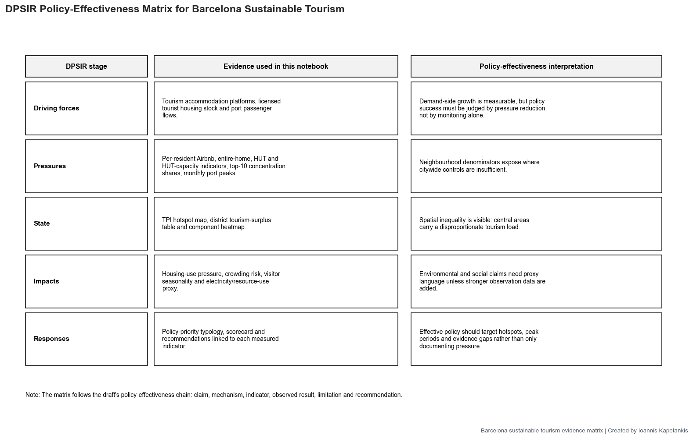

2.3 Carrying capacity as a composite pressure system
The concept of carrying capacity as an integrated, multilayered system composed of various constituent pressures than one predetermined fixed threshold number of tourists. To determine Barcelona's overall capacity as a destination, it'd involve considering aspects such as its capacity in relation to density of lodging, level of resident pressure (including residential displaced by tourists or tourism infrastructure), level of platform rental apartments, rate of flow through the cruise port, environmental impact due to emissions and consumption and concentration of tourist activities in particular neighborhoods (area specialization pressure) (Blanco-Romero et al., 2018; Milano et al., 2019).

2.4 Policy effectiveness and indicator-based evaluation
To assess policy effectiveness, it is used indicators than just descriptions of policy initiatives. Each policy is directly linked to measured data to observe whether Barcelona is successfully reducing the pressure posed by tourism or mostly serving to document, oversee and govern it more effectively (Barcelona Turisme, 2023; Ajuntament de Barcelona, 2024).

3. Methodology: Data, Indicators and Analytical Design
This paper utilizes a quantitative approach to policy making associating them with publicly available data and environment pressure proxies (Ajuntament de Barcelona, 2022).

3.1 Dataset architecture and sources
The empirical analysis basis on data sets from Barcelona Open Data BCN, Port de Barcelona and Inside Airbnb (Ajuntament de Barcelona, 2016; Port de Barcelona, n.d.). Open Data BCN is used for evaluation of commercial tourism activities measured by License given to owners, populations, administrative bounders, energy consumption and air quality monitoring (Ajuntament de Barcelona, 2017; Ajuntament de Barcelona, 2019; Ajuntament de Barcelona, 2020; Ajuntament de Barcelona, 2023). Port de Barcelona was used to monitor tourism, passenger traffic and subsequent pressure from commercial or transportational marine activities. Finally, inside Airbnb was used to track platformed accommodations and sort term rentals (Inside Airbnb, 2025).

3.2 Spatial and temporal units of analysis
The main spatial units used for the analysis were the neighbourhood. This is important due to the nature of tourism being ununiformed-heterogenous attributed in terms of spatial location. Where neighbourhood level evaluation is not possible data were aggregated to district level. The time series analysis uses quarterly panel data such as tourist housing data, annual electricity data, port passenger data by year and month and the most recent Airbnb extraction (Ajuntament de Barcelona, 2022; Colomb, 2017).

3.3 Indicator construction and mathematical formulas
The primary indicators are constructed as ratios of pressure and not as absolute sums. This represents better the neighbourhood with lower residents which may experience more pressure not in absolute value but in analog ratios compared to population (Dodds and Butler, 2019). Two given neighbourhood may have the same number of tourists occupy the area but one neighborhood to be smaller thus more pressure is exerted over it.
Tourist housing pressure is calculated as:
$$Tourist housing pressure =\frac{licensed tourist housing units}{resident population }*1000$$
Airbnb pressure is calculated as:
$$Airbnb pressure = \frac{Airbnb listings }{resident population }*1000$$
Entire home Airbnb pressure is calculated as:
$$Entire home pressure= \frac{entire home Airbnb listings }{resident population }*1000$$

Tourism pressure indexes are created by utilizing mean and median deviation pressure indicators and normalizing or rescaling the result from 0 up to 100. This allows neighbourhoods to be ranked on the combination of pressure vector applied to it.

3.4 Limitations: causality, proxies and data comparability
The above analysis does not cale necessarily that the causality between policy and outcomes is 100% but suggests a measurable approach. Tourism pressure is affected by an abundance of housing, transport, economic, and meta covid recovery factors (Morales-Pérez et al., 2024). As a subsequent effect electricity and air-quality data are therefore used as environmental pressure proxies, not as direct proof of tourism impact. The comparability of data is further hindered by the fact that the datasets utilize different geographic boundaries, time periods, and frequency of updates. As such, the exercise is mainly geared towards pattern recognition, pressure hot spots, and risk identification.

4. Barcelona’s Sustainable Tourism Policy Context
Barcelona could be judged an ideal case in a tourism governance system mature enough to be challenged by how effective it has been in addressing negative tourism impacts by measures like pressure reduction, spatial redistribution, peak reduction and environmental monitoring (Barcelona Turisme, 2023).

4.1 Sustainable tourism strategy and governance
The strategy laid out in the "Barcelona Sustainable Tourism Strategy 2023-2025" focuses on competitiveness, the wellbeing of residents, spatial territorial balance and the governance of sustainability (Barcelona Turisme, 2023). This essay's take on this policy context is that it sets out an intended intervention framework and says little about whether the measures are achieving their goals (Observatori del Turisme a Barcelona, 2025).

4.2 Accommodation regulation and platform pressure
Accommodation regulation can be assessed through the number of licensed Tourist Housing (HUT) units, Airbnb listings, the intensity of full home listings in accommodation units and the degree to which these are clustered in residential neighborhoods. Key is whether these regulated housing provision areas overlap with Airbnb clusters and exert overlapping or distinct pressure geography (Bei, 2025).

4.3 Visitor law, cruise and environmental management
Visitor flow policy can be judged given trends in cruise port passengers, cruise arrivals over the seasons and the peak ratio of tourist arrivals (Observatori del Turisme a Barcelona, 2026). Environmental management could be considered by examining the trends in electricity consumption or air quality metrics as simple urban pressure indicators than proven causes of urban problems (Ajuntament de Barcelona, 2018; Ajuntament de Barcelona, 2019).

4.4 Policy to indicator evaluation matrix
Policy area | Management objective | Indicator logic | Dataset
Sustainable tourism strategy | balanced economic, social and environmental governance | composite Tourism Pressure Index | Open Data BCN, Inside Airbnb, Port data
Accommodation regulation | control tourist housing pressure | HUT units per 1,000 residents | Open Data BCN
Platform accommodation | detect short - term rental pressure | Airbnb listings and entire homes per 1,000 residents | Inside Airbnb
Spatial balance | identify uneven neighbourhood exposure | tourism - unit share minus population share | Open Data BCN, Inside Airbnb
Cruise and visitor flows | identify temporal pressure peaks | monthly passengers and peak month ratio | Port de Barcelona
Environmental monitoring | assess resource and pollution pressure | electricity trend and air quality coverage | Open Data BCN
The policy indicator evaluation matrix turns the stated claims into an empirical test. The evaluation of Barcelona's management system shifts from checking the presence of sustainability based language and the enactment of policies aligned with it to a much stronger claim does the system reduce observed pressure (Barcelona Turisme, 2023).

5. Empirical analysis: Tourism pressure and sustainability outcomes
The empirical results show Barcelona's tourism pressure isn't spatially even, being concentrated in a small number of neighborhoods, the consequence of overlapping between registered housing, Airbnb, the share of apartment rentals and visitor demand central (Blanco-Romero et al., 2018).

5.1 Special concentration of licensed tourist housing
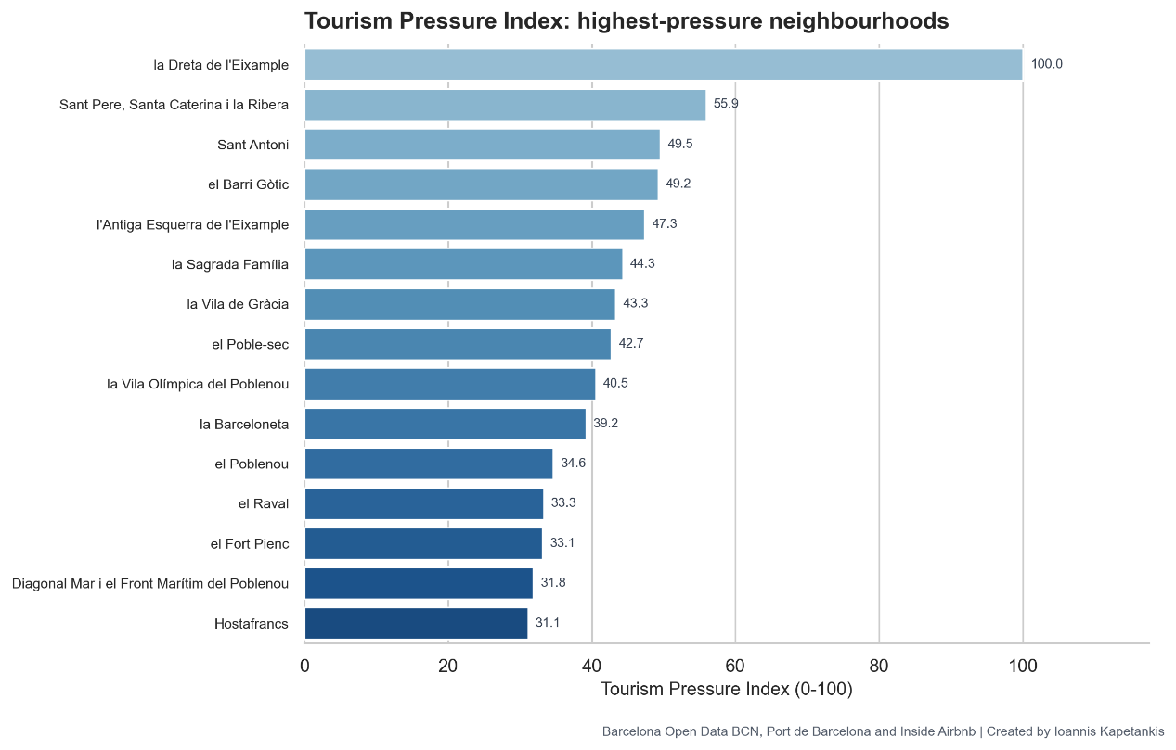Licensed housing for tourists, measured in licensed HUT, is spatially concentrated. The trend line demonstrates HUT licenses weren't distributed equally, indicating no effect from regulation toward achieving a balanced territorial spread of the offering of accommodation. This is a major problem since it's the density and not the total quantity of permits that may lead to negative impacts related to crowding in residential areas, a key dimension of tourism pressure (Cocola-Gant, 2016).

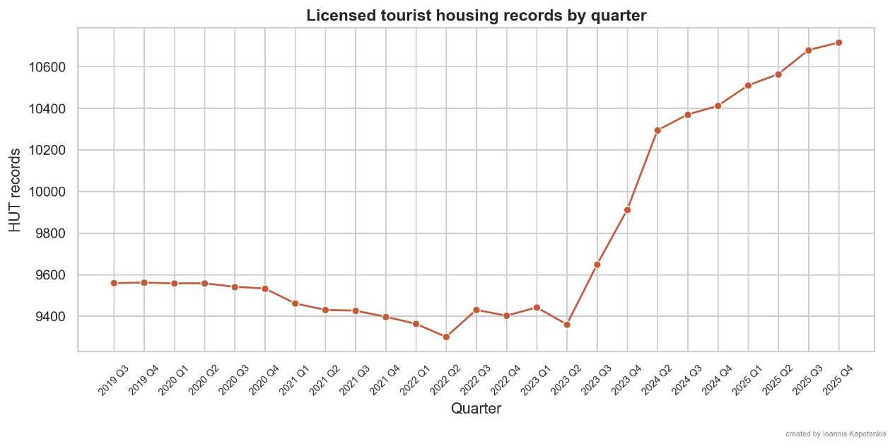 Moreover, the quarterly trend depicted of the register does not show continuous declines in licensed tourist housing, falling back from 2019 to 2022, sharply increasing to become higher in 2025 compared with previous years, in addition to registering periods with constant numbers between quarters of the 2016-2019 period, which must imply that regulation shouldn't be assumed as an automatically direct pressure reduction measure, but could also stand for the updating of registries, the adjustment to regulations or continued concentrated spatial distribution (Gyódi et al., 2025).
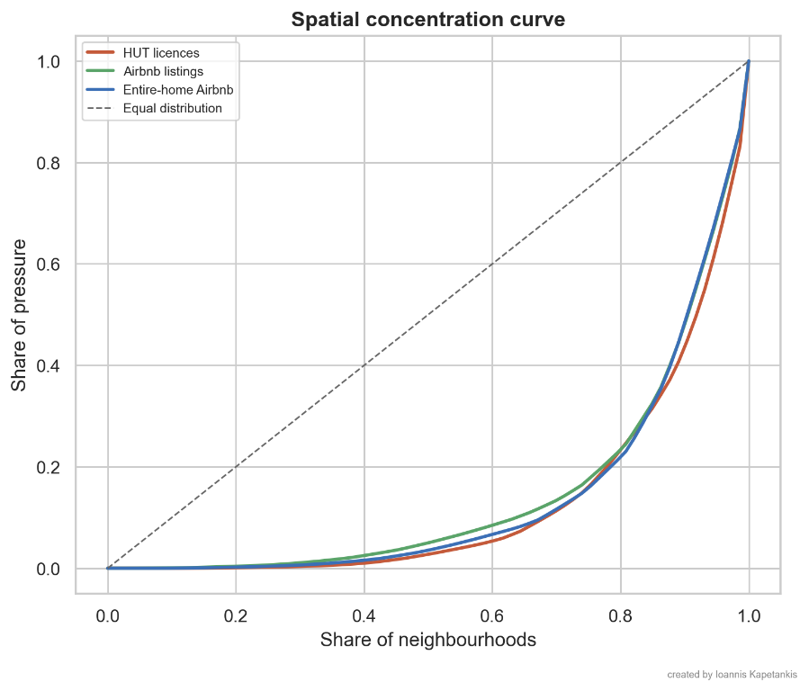

5.2 Airbnb and platform accommodation pressure
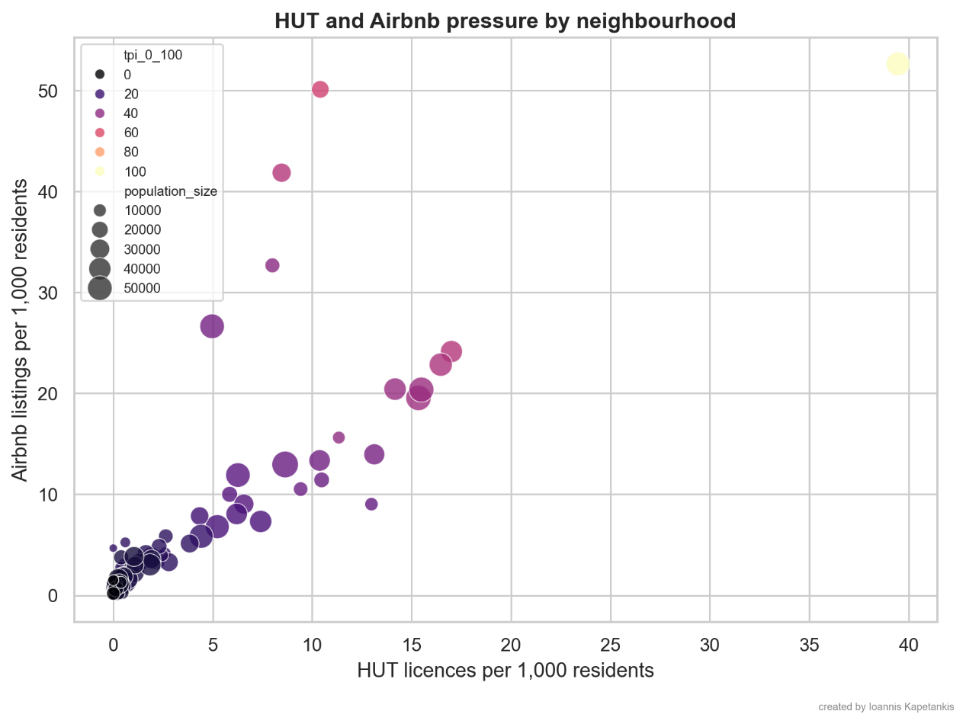
Platform pressure, measured through Airbnb intensity per thousand residents, generally follows the central city spatial orientation of HUT density but isn't the same pressure variable. The result is a clear positive correlation in places with dense Hut distribution, Airbnb density is typically also compact, nevertheless, several localities are considered as out of trend because of platform accommodation added pressure beyond the number of licenses in effect. It shows below with these data La Dreta de l'Eixample, followed by Sant Pere et al. as neighborhoods with high Airbnb intensity (Inside Airbnb, 2025). Air quality monitoring is used with methodological limitations and, although in the year of record growth, is in decline in the case of electricity consumption, it should be cautiously assessed rather than considered proof that tourism became more sustainable. Barcelona is suffering the consequences of tourism pressure, even when average spatially, city wise results fail to express the intensity of the problem, which can be more than average when only taking residential share or higher than in many parts of city wide statistics (Milano et al., 2024). Barcelona and the local pressure they endure need attention. 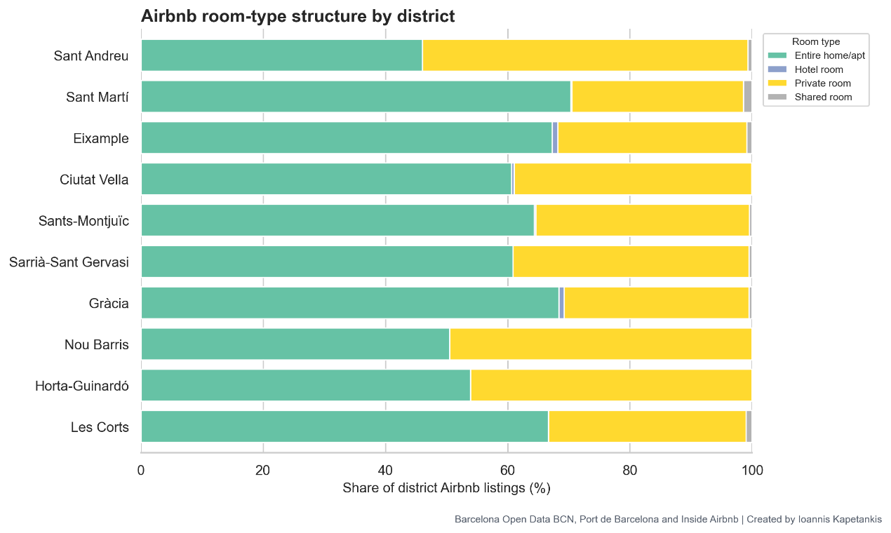

5.3 Housing and socioeconomic exposure
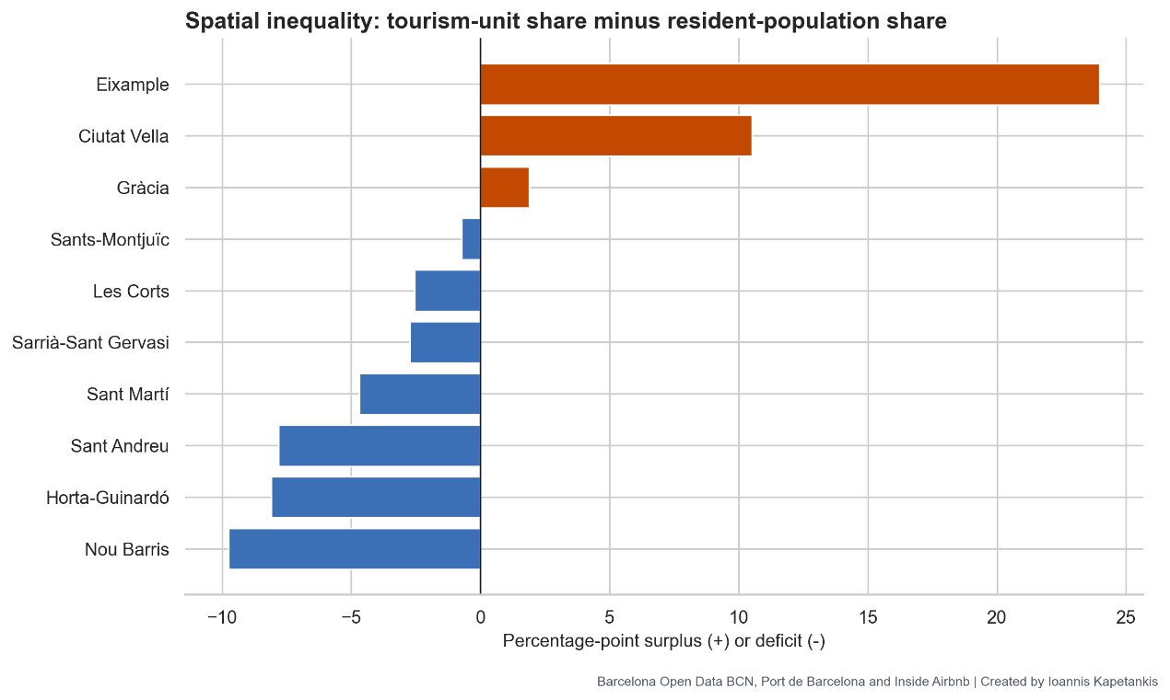
Tourism units are distributed unequally relative to how residents are geographically distributed. Eixample registers the biggest tourism unit surplus followed by Ciutat Vella. These two districts concentrate more tourism units proportionally to their share of Barcelona's population compared to their resident share in the population of the city (Inside Airbnb, 2025). By contrast, in other areas such as Nou Barris, Horta Guinardó or Sant Andreu, the tourism unit distribution records a deficit compared with the population share, which means that pressure on tourism accommodation is being exerted over certain city districts more than over other regions which mainly remain residential. Thus, when discussing city tourism in average terms for its residents, the spatial inequalities become invisibly averaged, and a visitor pressure can't be acknowledged.

5.4 Cruise and port passenger seasonality
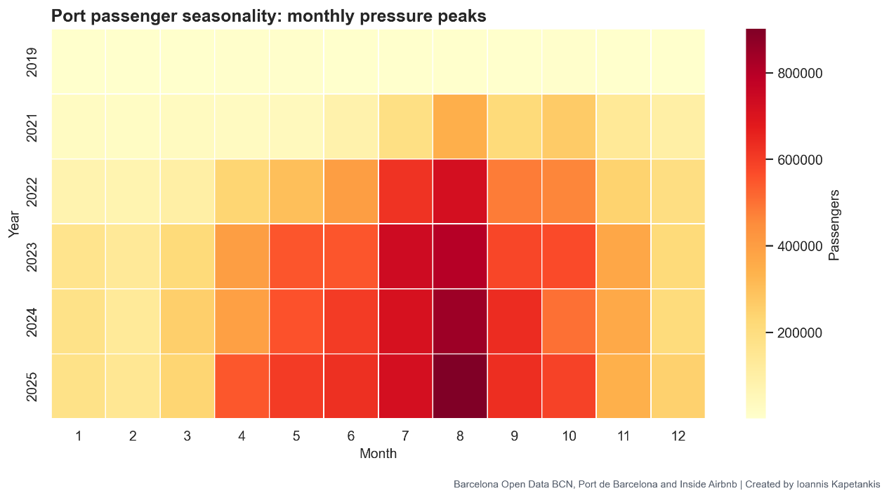
This shows monthly seasonality from Barcelona port data, highlighting how seasonality in cruise arrivals concentrates pressure during specific times (Port de Barcelona, n.d.). What matters about tourism capacity planning isn't so much how many annual passengers enter the city, but their arrival pattern, especially peak arrivals, such as those recorded in post COVID years (2023) (Observatori del Turisme a Barcelona, 2023). In fact, not all months share similar patterns of arrival for port passengers and even when monthly comparisons offer useful indications, a true reflection of operational pressure, in contrast with volume over time, would still require time based considerations for this kind of travel (Milano et al., 2019). 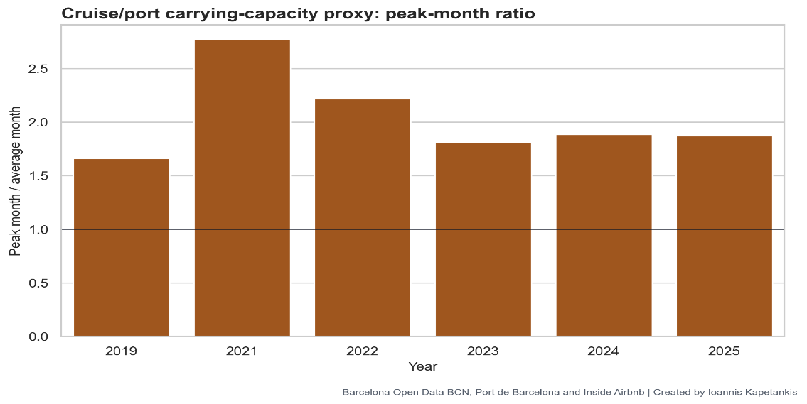

5.5 Environmental pressure proxies: electricity and air quality
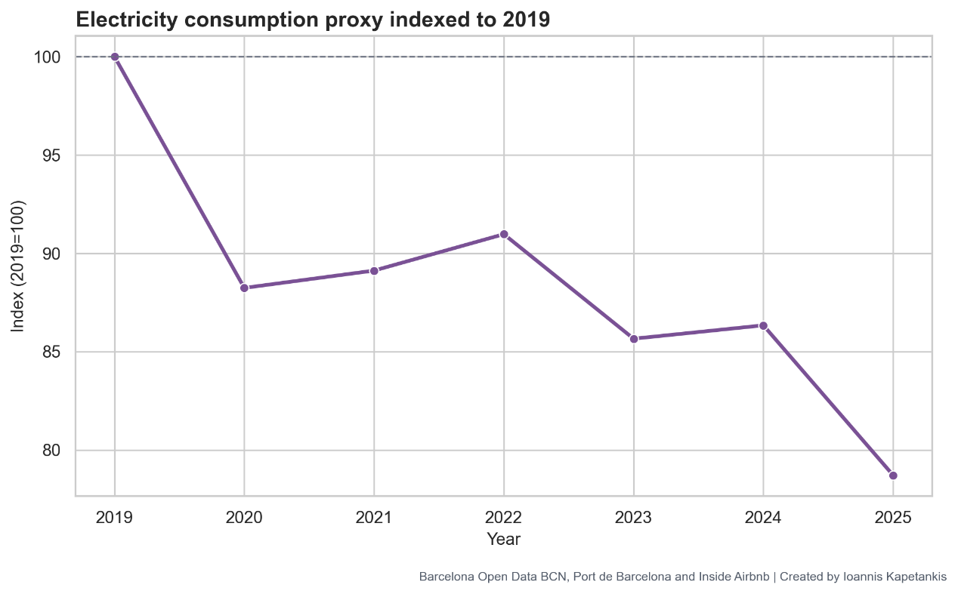
Data from Barcelona is used with precaution, since consumption of electricity indexed to the year of the record high in tourist levels (2019) declined by over 3% from the former year, although such reduction might be linked to multiple explanatory factors, such as energy efficiency, seasonal weather variability, economic downturns, data coverage gaps, changes related to post COVID-19 dynamics or a combination of all (Ajuntament de Barcelona, 2022; Observatori del Turisme a Barcelona, 2026).

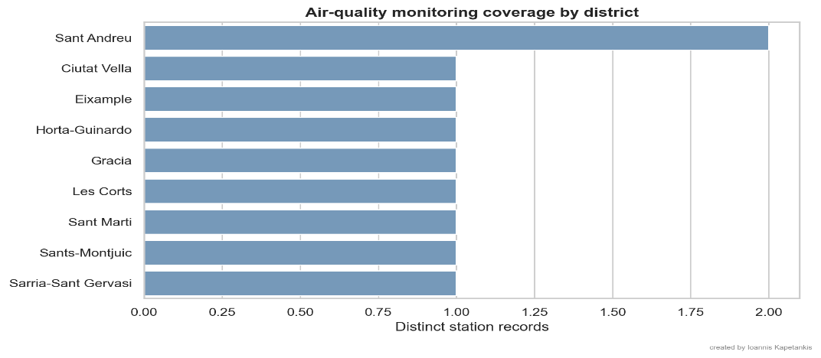
On top, environmental monitoring doesn't reach all areas equally well, thus an accurate measure of tourism pressure on the environment based on local monitoring cannot be performed for the purpose of drawing strong environmental sustainability claims based only on this available data, recommending a careful analysis given measurement limitation (Ajuntament de Barcelona, 2018; Ajuntament de Barcelona, 2019).

5.6 Composite Tourism Pressure Index
A combination of these six pressure measures into a single neighborhood level Tourism Pressure Index (TPI). La Dreta de l'Eixample comes out on top as a hotspot with a score of 100. Second on the ranking, Sant Pere, Santa Caterina i la Ribera, with a score of 55.9, shows that the dominant hot spot is far ahead of other high pressure areas, demonstrating it's not just another area facing high tourism pressure. Some of the other top hotspots include Sant Antoni, El Barri Gòtic, l'Antiga Esquerra de l'Eixample, la Sagrada Familia, and more, highlighting that the concentrated areas tend to be in the city center, tourist attractions, areas with excellent access or symbolic value for tourists (Inside Airbnb, 2025).

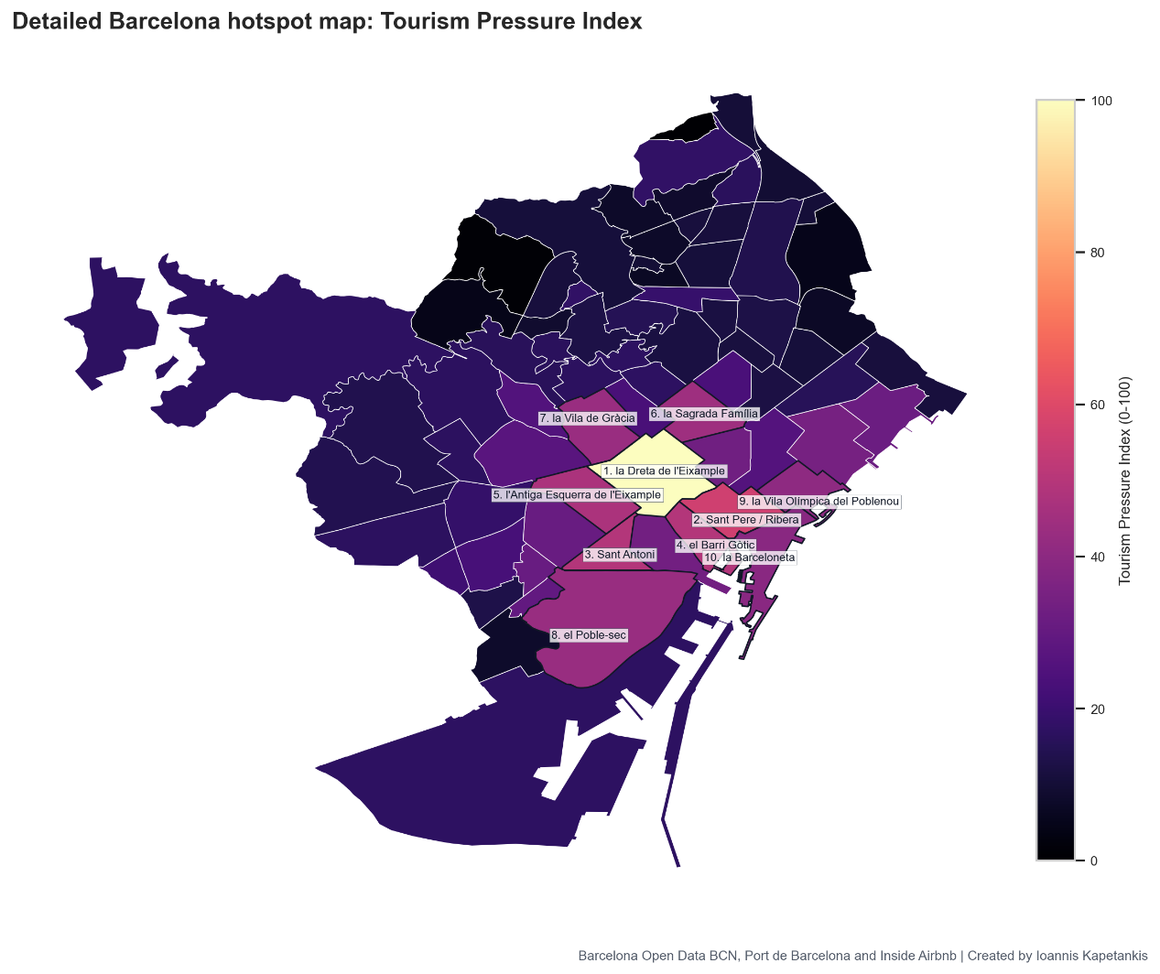
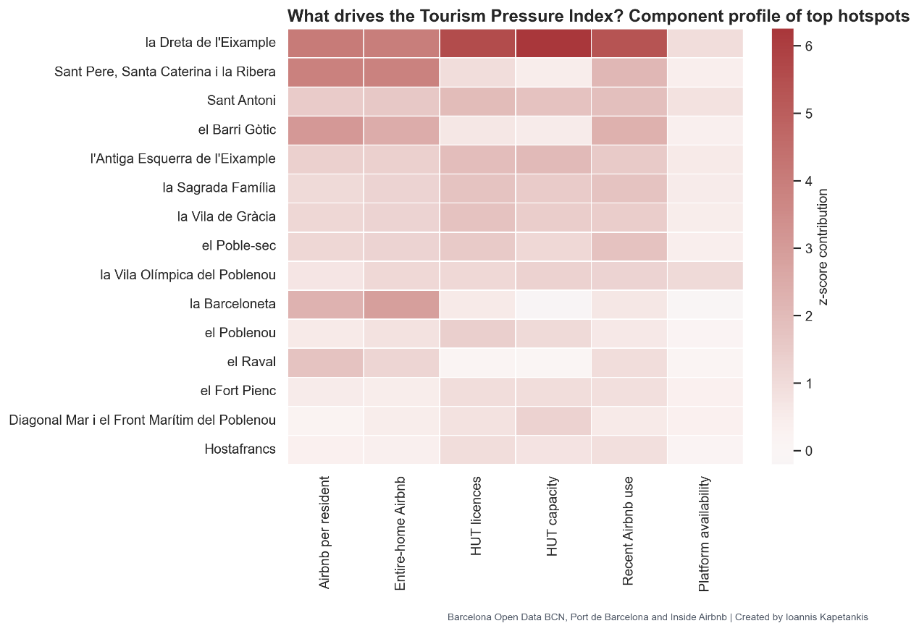
The heat map reinforces this finding: these highest pressure regions aren't defined by a single pressure factor but by a combination of Airbnb, shared apartment rentals, licenses for tourist accommodation, HUT capacity and more recently, platforms for rentals, demonstrating that tourism pressure is an intertwined multi component systemic issue affecting Barcelona city than simply too many tourists flooding the city in large numbers (Gutiérrez et al., 2017).


6. Critical evaluation of management effectiveness
Barcelona's advanced model could achieve positive results with the correct managers. Figures, such as TPI and choropleth, show that while management exists, they're unable to reduce visitor pressure (Barcelona Turisme, 2023; Ajuntament de Barcelona, 2024). They successfully collect and analyze visitors’ relevant data; however, they fail to carry out actions that truly limit the effects of tourism (Observatori del Turisme a Barcelona, 2026). The city is not unmanaged, it's over measured but still fundamentally exposed to extreme pressures.

6.1 Strengths of Barcelona's governance model
Barcelona possesses substantial administrative capabilities to manage tourism its strategy document, a significant repository of open data on visitors and tourism flows, HUT regulations that limit the duration of stays for temporary tourist homes, Port of Barcelona official data, city wide tourism monitoring instruments and public agencies working on tourism management ensure that Barcelona's governance can measure visitor pressure at a neighbourhood, city district and even monthly basis (Barcelona Turisme, 2023).
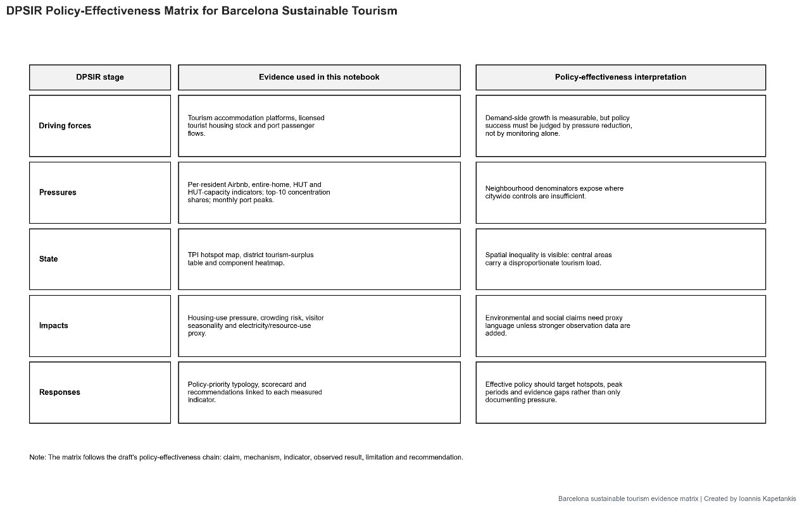

6.2 Limitations and policy - performance gaps
The fundamental limitation is that while monitoring and measurement mechanisms are in place, these don't currently translate into effective visitor control. The TPI demonstrates extreme spatial concentration, as most pressure exists inla Dreta de l'Eixample and choropleths clearly reflect visitor pressure on a cluster of central neighborhoods, not even distribution throughout the entire city (Gutiérrez et al., 2017).

Accommodation regulations are evidently still too lax and insufficient to limit Airbnb induced tourism pressures. The findings indicate that HUT density and Airbnb density appear to coincide geographically in many places, indicating that current regulations fail to fully nullify platform driven pressures on tourism pressure hotspots ( Gyódi et al., 2025). In fact, legal HUTs, Airbnb’s listing entire houses for rent and the abundance of available units seem to converge in the same urban zones (Ajuntament de Barcelona, 2016).

Socio spatial inequalities in Barcelona remain a fundamental failure, in that residents in the Eixample and Ciutat Vella bear a surplus of tourism units compared with their share of Barcelona's total resident population, denoting an unbalanced distribution between the two groups, not a sustainable one for tourism managers (Blanco-Romero et al., 2018).


Data obtained from the Cruise and Port of Barcelona clearly shows that Spain and Barcelona are failing on carrying capacity measures at a temporal level, since high occupancy peaks in the summertime may conceal real, temporary overtourism through averages spread over an entire year. The destination could seem manageable by taking a holistic yearly perspective, but it could be well over its carrying capacity in the hottest months, just as cruising pressure during the winter is low but peaks high in August (Observatori del Turisme a Barcelona, 2026).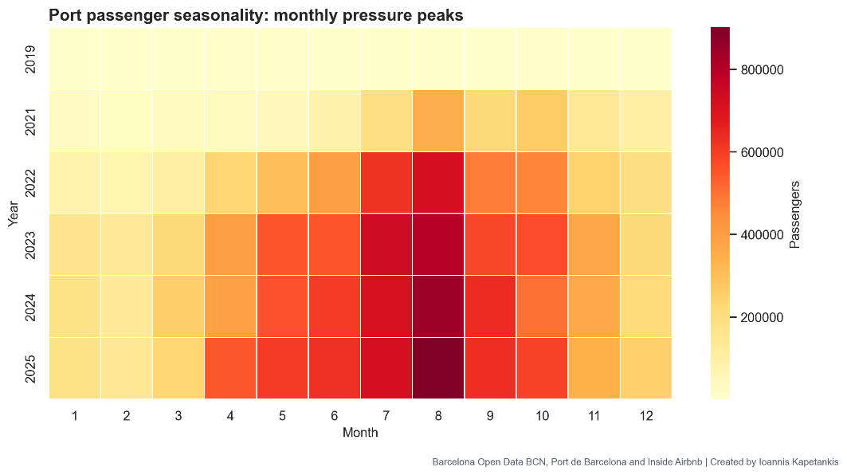

6.3 Overall judgment: monitoring capacity versus pressure reduction
The efforts of Barcelona's government towards sustainable tourism management have proven technically sophisticated but weak in terms of performance (Russo and Scarnato, 2018; Barcelona Turisme, 2023). Data gathered strongly points to the fact that Barcelona is currently already suffering from overtourism, not only at a hypothetical risk in the future (Milano et al., 2024).
Given this pattern of increasing pressure over the years, there's a serious potential for deepening socio cultural disruption, such as resident displacement pressures, increased vacant housing, loss of neighbourhood function, cultural commodification, conflict between the visitor economy and the everyday lives of residents (Cocola-Gant, 2016).
The evaluation of management effectiveness is clear Barcelona isn't failing due to a lack of policies. The city is failing because its policies aren't succeeding in effectively imposing strict limits to the spatial and temporal concentration of tourists, which is slowly eroding what makes Barcelona so livable and vibrant. Barcelona's current sustainability model has the potential to transform into a sophisticated monitoring instrument of an already unbearable tourism urban structure (Observatori del Turisme a Barcelona, 2025).

7. General Recommendations
Instead of policy, Barcelona needs a program focused on an integrated approach towards actively managing its tourist destination (Mason, 2020). High pressure neighborhoods will need to become "zones of tourist pressure" for management, regulating group tours, buses, cruise tours, pedestrian tours and attraction slot access based on pressure measurements. Within the zones of highest pressure, there should be measures to limit group size, and reroute visitors away from busy streets. The DMO should scale back marketing for overloaded areas and focus promotion of low season offerings, off beat neighborhoods, historical routes, food, drink scenes, the creative industries and metropolises instead (Barcelona Turisme, 2023). However, visitor dispersal should also be implemented thoughtfully with capacity monitoring and resident collaboration or the overtourism problem will be relocated (Milano et al., 2019). Cruise passengers, like residents and day trippers, are users of Barcelona's public space. Cruise activities must, therefore, be considered as part of the city's capacity issue, then a port matter alone. Cruise ships should be synchronized to consider public transport schedules, coach routes and attraction volumes. Success shouldn't be quantified through visitor numbers alone, but through "net destination value”. This refers to visitors' contribution in terms of expenditure, duration, local benefit, tolerance of residents, protection of the local culture and the decrease of pressure on sensitive areas (Hughes et al., 2015).

8. stakeholders’ analysis
Stakeholder | Power | Exposed | Main interest | Conflict logic | Indicator link
Barcelona City Council | High | Medium | regulation, social balance, tax return | resident pressure vs tourism economy | policy actions, HUT controls
Turisme de Barcelona / DMO | High | Medium | destination competitiveness, branding, sustainability positioning | growth logic vs pressure reduction | strategy, certification, promotion
Residents | Medium | High | housing affordability, liveability, noise, crowding | social carrying capacity vs visitor economy | TPI, Airbnb pressure, spatial inequality
HUT owners | Medium | Medium | licence value, rental income, regulatory stability | private return vs housing pressure | HUT per 1,000 residents
Airbnb hosts / platforms | High | Medium | platform supply, occupancy, flexibility | informal growth vs enforceable control | Airbnb listings, entire-home share
Hotels | High | Low-Medium | occupancy, ADR, regulated competition | formal sector vs platform sector | accommodation mix
Port authority / cruise operators | High | Medium | passenger volume, port revenue, scheduling | volume growth vs peak pressure | port seasonality, peak-month ratio
Tourists | Low | Low | access, price, experience quality | consumption freedom vs local limits | demand concentration
Local businesses | Medium | Medium | footfall, spending, survival | revenue dependence vs overtourism costs | spatial hotspots
Environmental / social NGOs | Medium | Medium | accountability, conservation, resident rights | ecological/social limits vs growth | air quality, energy, SDG links

Appendices
Definitions:
DPSIR (drivers, pressures, state, impact, and response model of intervention) is a causal framework used to describe the interactions between society and the environment. It seeks to analyze and assess environmental problems by bringing together various scientific disciplines, environmental managers, and stakeholders, and solve them by incorporating sustainable development.
The triple bottom line (TBL) is a sustainability framework that revolves around the three P’s: people, planet and profit. By maximizing all three bottom lines, organizations are more likely to have a positive impact on the world while still improving financial performance.
Open Data or Public Sector Information Openness is a movement driven by public administrations with the main objective of maximizing available public resources, exposing the information generated or guarded by public bodies, allowing its access and use for the common good and for the benefit of anyone and any entity interested.
A heat map (or heatmap) is a two-dimensional data visualization technique that represents the magnitude of individual values within a dataset as a color. The variation in color may be by hue or intensity.
Tourism Pressure Index (TPI) quantifies logistic, social, and natural variables.
A destination marketing organization (DMO) is an organization which promotes a location as an attractive travel destination. DMOs are also known as tourist boards, tourism authorities or Convention and Visitors Bureaus. They primarily exist to provide information to leisure travelers. Additionally, where a suitable infrastructure exists, they encourage event organizers to choose their location for meetings, incentives, conferences, and exhibitions, collectively abbreviated as MICE.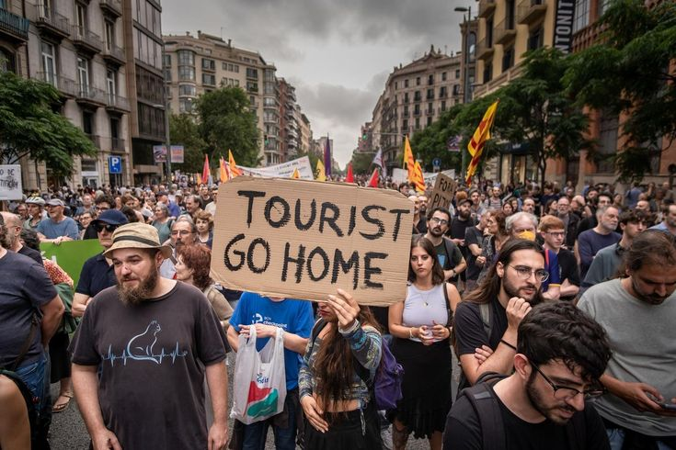

References
- Ajuntament de Barcelona (2016) Tourist housing in the city of Barcelona [Dataset]. Open Data BCN. Available at: https://opendata-ajuntament.barcelona.cat/data/en/dataset/c748799e-1079-44b1-9e60-88d936a3fe70 (Accessed: 6 May 2026).
- Ajuntament de Barcelona (2018) Air quality measure stations of the city of Barcelona [Dataset]. Open Data BCN. Available at: https://opendata-ajuntament.barcelona.cat/data/en/dataset/qualitat-aire-estacions-bcn (Accessed: 6 May 2026).
- Ajuntament de Barcelona (2019) Measured air pollutants by the air quality measurement stations of the city of Barcelona [Dataset]. Open Data BCN. Available at: https://opendata-ajuntament.barcelona.cat/data/en/dataset/contaminants-estacions-mesura-qualitat-aire (Accessed: 6 May 2026).
- Ajuntament de Barcelona (2020) Administrative units of the city of Barcelona [Dataset]. Open Data BCN. Available at: https://opendata-ajuntament.barcelona.cat/data/en/dataset/20170706-districtes-barris (Accessed: 6 May 2026).
- Ajuntament de Barcelona (2022) Electricity consumption by postal code, economic sector and time interval in the city of Barcelona [Dataset]. Open Data BCN. Available at: https://opendata-ajuntament.barcelona.cat/data/en/dataset/consum-electricitat-bcn (Accessed: 6 May 2026).
- Ajuntament de Barcelona (2023) Population by age [Dataset]. Open Data BCN. Available at: https://opendata-ajuntament.barcelona.cat/data/en/dataset/pad_mdbas_edat-1 (Accessed: 6 May 2026).
- Ajuntament de Barcelona (2024) Barcelona seeks to boost harmony between tourism and the city through a new government measure. Available at: https://turismesostenible.barcelona/en/news/106/barcelona-seeks-to-boost-harmony-between-tourism-and-the-city-through-a-new-government-measure (Accessed: 6 May 2026).
- Ajuntament de Barcelona. (2017). Administrative units of the city of Barcelona [Dataset]. Open Data BCN. Retrieved May 6, 2026, from https://opendata-ajuntament.barcelona.cat/data/dataset/20170706-districtes-barris
- Ajuntament de Barcelona. (2024). Mesura de Govern per a la Gestió Turística 2024-2027 [Policy document]. BCNROC. https://bcnroc.ajuntament.barcelona.cat/jspui/handle/11703/137522
- Barcelona Turisme (2023) Sustainable Tourism Strategy 2023–2025. Available at: https://barcelonaturisme.com/uploads/web/bst/EstrategiaTurismeSostenibleBarcelonaTurisme23-25_ENG.pdf (Accessed: 6 May 2026).
- Bei, G. (2025). The spatial effect of short-term rental regulations: The comparison between Barcelona and Paris. Cities, 158, 105603. https://doi.org/10.1016/j.cities.2024.105603
- Blanco-Romero, A., Blázquez-Salom, M., & Cànoves, G. (2018). Barcelona, Housing Rent Bubble in a Tourist City. Social Responses and Local Policies. Sustainability, 10(6), 2043. https://doi.org/10.3390/su10062043
- Cocola-Gant, A. (2016). Holiday Rentals: The New Gentrification Battlefront. Sociological Research Online, 21(3), 35–43. https://doi.org/10.5153/sro.4071
- Colomb, C., & Novy, J. (Eds.). (2017). Protest and resistance in the tourist city. Routledge. https://www.routledge.com/Protest-and-Resistance-in-the-Tourist-City/Colomb-Novy/p/book/9781138342248
- Crespi-Vallbona, M., & López-Villanueva, C. (2024). Citizen actions in touristic neighbourhoods: Barcelona as a case study. Current Issues in Tourism, 27(1), 19–36. https://doi.org/10.1080/13683500.2023.2218603
- Dodds, R., & Butler, R. W. (Eds.). (2019). Overtourism: Issues, realities and solutions. De Gruyter Oldenbourg. https://doi.org/10.1515/9783110607369
- García-López, M.-À., Jofre-Monseny, J., Martínez-Mazza, R., & Segú, M. (2020). Do short-term rental platforms affect housing markets? Evidence from Airbnb in Barcelona. Journal of Urban Economics, 119, 103278. https://doi.org/10.1016/j.jue.2020.103278
- Gutiérrez, J., García-Palomares, J. C., Romanillos, G., & Salas-Olmedo, M. H. (2017). The eruption of Airbnb in tourist cities: Comparing spatial patterns of hotels and peer-to-peer accommodation in Barcelona. Tourism Management, 62, 278–291. https://doi.org/10.1016/j.tourman.2017.05.003
- Gyódi, K., Mazur, J., & Cocola-Gant, A. (2025). Barcelona as a case study for the effectiveness of short-term rental market regulations. Cities, 162, 105915. https://doi.org/10.1016/j.cities.2025.105915
- Hall, C. M., Gössling, S., & Scott, D. (Eds.). (2015). The Routledge handbook of tourism and sustainability. Routledge. https://www.routledge.com/The-Routledge-Handbook-of-Tourism-and-Sustainability/Hall-Gossling-Scott/p/book/9781138071476
- Hughes, M., Weaver, D., & Pforr, C. (Eds.). (2015). The practice of sustainable tourism: Resolving the paradox. Routledge. https://www.routledge.com/The-Practice-of-Sustainable-Tourism-Resolving-the-Paradox/Hughes-Weaver-Pforr/p/book/9781138083950
- Inside Airbnb (2025) Barcelona, Catalonia, Spain: listings, calendar, reviews and neighbourhood data [Dataset]. Available at: https://insideairbnb.com/get-the-data/ (Accessed: 6 May 2026).
- Koens, K., Postma, A., & Papp, B. (2018). Is Overtourism Overused? Understanding the Impact of Tourism in a City Context. Sustainability, 10(12), 4384. https://doi.org/10.3390/su10124384
- Mason, P. (2020). Tourism impacts, planning and management (4th ed.). Routledge. https://www.routledge.com/Tourism-Impacts-Planning-and-Management/Mason/p/book/9780367221621
- Milano, C., Cheer, J. M., & Novelli, M. (Eds.). (2019). Overtourism: Excesses, discontents and measures in travel and tourism. CABI. https://doi.org/10.1079/9781786399823.0000
- Milano, C., Novelli, M., & Cheer, J. M. (2019). Overtourism and Tourismphobia: A Journey Through Four Decades of Tourism Development, Planning and Local Concerns. Tourism Planning & Development, 16(4), 353–357. https://doi.org/10.1080/21568316.2019.1599604
- Milano, C., Novelli, M., & Russo, A. P. (2024). Anti-tourism activism and the inconvenient truths about mass tourism, touristification and overtourism. Tourism Geographies, 26(8), 1313–1337. https://doi.org/10.1080/14616688.2024.2391388
- Morales-Pérez, S., Meseguer-Artola, A., Garay-Tamajón, L. A., & Lladós-Masllorens, J. (2024). Inside Airbnb’s performance and adaptive strategies in Barcelona using artificial neural networks: A longitudinal, spatial, and multi-host perspective. Journal of Hospitality and Tourism Management, 59, 238–250. https://doi.org/10.1016/j.jhtm.2024.04.010
- Morrison, A. M., & Coca-Stefaniak, J. A. (Eds.). (2021). Routledge handbook of tourism cities. Routledge. https://www.routledge.com/Routledge-Handbook-of-Tourism-Cities/Morrison-Coca-Stefaniak/p/book/9780367524630
- Observatori del Turisme a Barcelona (2025) Excursionists data base. Tourist profile and habits in Destination Barcelona 2024 [Dataset]. Available at: https://observatoriturisme.barcelona/en/documentacio/base-de-dades-excursionistes-perfil-i-habits-del-turista-a-la-destinacio-barcelona-2024/ (Accessed: 6 May 2026).
- Observatori del Turisme a Barcelona (2025) Individuals data base. Tourist profile and habits in Destination Barcelona 2024 [Dataset]. Available at: https://observatoriturisme.barcelona/en/documentacio/base-de-dades-individus-perfil-i-habits-del-turista-a-la-destinacio-barcelona-2024/ (Accessed: 6 May 2026).
- Observatori del Turisme a Barcelona (2026) 2025 Annual Report of the Barcelona Tourism Observatory: Data 2024 [Report]. Available at: https://pre-webunwto.s3.eu-west-1.amazonaws.com/s3fs-public/2026-03/2025%20Annual%20Report%20of%20the%20Barcelona%20Tourism%20Observatory%20%28Data%202024%29.pdf?VersionId=arCwANkHQSbtHI1jlSqgn484cqemdawM (Accessed: 6 May 2026).
- Observatori del Turisme a Barcelona. (2022). SITS - OTB: The OTB Sustainable Tourism Indicators System [Indicator system]. Retrieved May 6, 2026, from https://observatoriturisme.barcelona/en/sustainability-sits-otb-otb-sustainable-tourism-indicators-system/
- Observatori del Turisme a Barcelona. (2025). Individuals data base. Tourist profile and habits in Destination Barcelona 2024 [Dataset]. Retrieved May 6, 2026, from https://observatoriturisme.barcelona/en/documentacio/base-de-dades-individus-perfil-i-habits-del-turista-a-la-destinacio-barcelona-2024/
- Port de Barcelona (n.d.) Passenger traffic statistics [Dataset]. Open Data Port de Barcelona. Available at: https://opendata.portdebarcelona.cat/en/dataset/estadistiques-de-trfic-de-passatgers (Accessed: 6 May 2026).
- Russo, A. P., & Scarnato, A. (2018). “Barcelona in common”: A new urban regime for the 21st-century tourist city? Journal of Urban Affairs, 40(4), 455–474. https://doi.org/10.1080/07352166.2017.1373023

